COIT20265: Networks and Information Security Project

Assessment 1 Part A

Submitted to:
Unit coordinator:
Biplob Roy

Mentor:
Ahmedi Azra

Submitted by:
Md Yeakub 12289551

Date of submission
16 April 2026

Contents
Introduction 3
1) Alignment with Project Proposal 3
2) Progress Demonstration 4
3) Personal Contribution 5
4) Requirements for Development Progress: 6
5) Model and Documentation Refinement 8
6) Path to Final Deliverables 10
7) Depth of Analysis 11
Memory-Efficient Data Engineering 11
TF-IDF Configuration and Vocabulary Control 11
Isolation Forest Mechanics and Score Interpretation 12
Quantitative Results 12
8) Cross-Algorithm Comparison and Methodology 15
9) Summary of Progress 16
10) Critical Self-Assessment 16
11) Challenges and Problem-Solving. 17
12) Evidence of Learning and Improvement 18
13) Future Thinking: 19

Natural Language Processing for Cybersecurity
Introduction: This project focuses on detecting anomalies in large-scale HDFS log data using machine learning techniques. The main objective is to design, implement, and compare different algorithms, including Random Forest, Isolation Forest, and LogBERT, to identify the most effective approach. The work involves handling raw log data, applying preprocessing techniques such as cleaning and TF-IDF, and analyzing model performance. A key challenge addressed in this project is managing large datasets efficiently while maintaining meaningful feature representation. Based on comparative analysis, the most suitable model is selected for anomaly detection and that is LogBERT. The project also aims to extend this work towards a real-world application by integrating log monitoring with AWS services for real-time analysis and visualization.
1) Alignment with Project Proposal: In the Project Proposal, my designated role was that of a Data Analyst. While the proposal did not specify a particular algorithm, the responsibilities attached to the data analyst role included managing and preprocessing data, selecting appropriate analytical methods, evaluating model performance, and guiding the team toward the most suitable technical solution. All of the work I have completed throughout this project directly reflects those responsibilities.
My primary delivery was the design, implementation, and evaluation of the TF-IDF + Isolation Forest algorithm applied to the HDFS_v2 dataset. This task encompassed every stage of the data analysis lifecycle — from raw data ingestion and memory-safe preprocessing, to feature extraction, model training, anomaly score generation, and result interpretation. Beyond implementing my own model, I also took on the broader analytical responsibility of comparing all three algorithms (Random Forest, Isolation Forest, and LogBERT) and producing a structured comparison document to determine which model was best suited for the project's goals.
This comparison work was a direct extension of my data analyst role. It required understanding not just my own algorithm but also the approaches taken by my teammates, evaluating them against common criteria such as dataset type, model type, evaluation metrics, and anomaly detection suitability. The conclusion drawn — that LogBERT is the strongest overall model — was the result of a systematic analytical process I led and documented. Every task I completed maps clearly back to the role and responsibilities outlined at the start of the project.

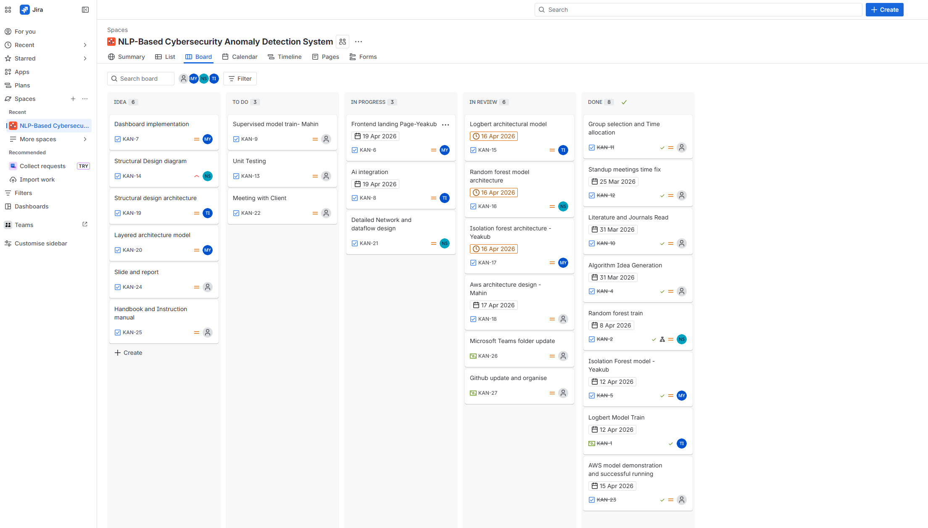

2) Progress Demonstration: The progress I made throughout this project was both measurable and meaningful, with concrete outcomes at every stage.
On the data handling side, I successfully processed the HDFS_v2 dataset — a large-scale, raw log file — using a chunk-based reading approach with a chunk size of 20,000 rows per iteration. This allowed me to safely sample up to 120,000 log entries without causing memory overflow or kernel crashes, which were genuine risks when working with a file of this size. The preprocessing pipeline I developed cleaned and normalised each log entry, and filtered out entries shorter than 20 characters to remove noise. This resulted in a clean, usable dataset of sampled logs ready for feature extraction.
On the modelling side, the Isolation Forest model was successfully trained on TF-IDF vectors derived from the cleaned HDFS_v2 logs. The model produced measurable results: out of 120,000 sampled log entries, 114,535 were classified as normal and 5,465 were flagged as anomalies, representing a 5% contamination rate consistent with the model's configuration. The anomaly scores had a mean of 0.4253 and a maximum of 0.6880, providing a quantifiable output that could be directly compared against the scores produced by LogBERT and Random Forest.
On the analytical side, the comparison document I produced represents a meaningful piece of progress for the project as a whole. It allowed the team to move from three separate individual models to a clearly justified shared conclusion: that LogBERT is the best model for the final pipeline. The score summary table, qualitative explanations, and final algorithm selection section in the document demonstrate that I did not simply implement a model in isolation — I used the results to inform a real decision that shaped the direction of the entire project.
Taken together, these outputs show a clear trajectory of progress: from raw data, to clean features, to a trained model, to evaluated results, to a cross-algorithm comparison, to a final recommendation.
3) Personal Contribution: My individual contributions are clearly distinct from those of my teammates, both in terms of the algorithm I implemented and the analytical work I produced independently.
Each team member was responsible for a different algorithm. My two teammates implemented Random Forest (on the HDFS_v1 preprocessed dataset) and LogBERT (on session-based sequences derived from HDFS_v2). My own contribution was the Isolation Forest pipeline, which I applied to the raw HDFS_v2 dataset. While all three models were eventually compared in a shared document, the implementation of each model was done independently by the assigned team member.
My work is distinguishable in several specific ways. The dataset I worked with — HDFS_v2 in its raw, large-scale form — required a different and more complex preprocessing strategy than the one used for Random Forest, which relied on the already-structured HDFS_v1 dataset. The memory-safe chunk-based reading, the custom log cleaning function, and the TF-IDF configuration I used were all written and tested by me. The Isolation Forest model is also an unsupervised method, which is conceptually and technically distinct from the supervised Random Forest used by one teammate and the deep learning sequence model used by another.
Beyond the implementation, the algorithm comparison document was also my individual contribution. While the results and explanations for each model were written with knowledge of all three approaches, the document itself — including the analytical framework used to compare them, the identification of why Isolation Forest is a closer baseline to LogBERT than Random Forest, and the final recommendation — was produced by me as part of my data analyst responsibilities. This document represents a layer of contribution that sits above individual model implementation and reflects the broader analytical judgement expected of the data analyst role.
In summary, my individual work is evidenced by a distinct algorithm, a distinct dataset, a distinct preprocessing approach, and an independent analytical output that contributed to the project's overall direction and final model selection.

4) Requirements for Development Progress:
From the outset of the project, my role as Data Analyst required me to identify the most appropriate approach for handling cybersecurity log data and selecting a suitable anomaly detection method. This work directly drove the technical requirements for the entire data pipeline.

The first requirement I made was around dataset selection. The HDFS_v2 dataset — a large-scale, raw HDFS log file — was chosen as the primary data source for my Isolation Forest pipeline. This was a deliberate and justified decision. Unlike the structured HDFS_v1 dataset used in the Random Forest approach, HDFS_v2 presented far greater realism and complexity, with raw merged log messages that required careful preprocessing before any modelling could take place. Selecting this dataset reflected an understanding of what the project genuinely needed: a realistic and challenging log environment to test anomaly detection.

From this dataset choice, several specific technical requirements emerged naturally. The preprocessing pipeline had to be memory-safe, meaning it could not attempt to load the entire file into RAM at once. The feature extraction method needed to handle raw unstructured text. The anomaly detection model had to operate without requiring labelled data. Each of these requirements shaped the decisions made in code, and all of them are reflected directly in the final implementation.

A key technical requirement I identified early was the need for chunk-based data processing. The HDFS_v2 file size made standard single-load reading completely impractical. The requirement was formally addressed in code by setting a CHUNK_SIZE of 20,000 rows and a MAX_SAMPLES cap of 120,000. This was not an arbitrary choice — it was based on balancing the need for a representative sample against the memory constraints of the environment.

The following code block demonstrates how chunk-based ingestion was implemented to meet this requirement:

MAX_SAMPLES = 120000 # safe upper bound for memory
CHUNK_SIZE = 20000 # rows per iteration

sample_texts = []
kept = 0

chunk_iter = pd.read_csv(
LOG_FILE,
usecols=["merged_log"],
dtype={"merged_log": "string"},
chunksize=CHUNK_SIZE,
low_memory=True
)

for i, chunk in enumerate(chunk_iter, start=1):
chunk = chunk.dropna(subset=["merged_log"]).copy()
chunk["clean_text"] = chunk["merged_log"].map(clean_log_text)
chunk = chunk[chunk["clean_text"].str.len() > 20]
remaining = MAX_SAMPLES - kept
if remaining <= 0:
break
take_n = min(len(chunk), remaining)
sample_texts.extend(chunk["clean_text"].iloc[:take_n].tolist())
kept += take_n
del chunk
gc.collect()

Another key requirement was the need to normalise raw log text before feature extraction. Raw HDFS logs contain IP addresses, numeric block IDs, and repeated structural characters that would inflate the vocabulary and distort TF-IDF weights. My text cleaning function addressed this requirement by converting log entries to lowercase, replacing IP addresses with a placeholder token 'IP', replacing numeric values with 'NUM', and stripping special characters. This produced a clean, consistent input representation for TF-IDF vectorisation.

ip_pattern = re.compile(r"\b(?:\d{1,3}\.){3}\d{1,3}\b")
num_pattern = re.compile(r"\b\d+\b")

def clean_log_text(text):
text = str(text).lower()
text = ip_pattern.sub(" IP ", text)
text = num_pattern.sub(" NUM ", text)
text = re.sub(r"[^a-z_ ]+", " ", text)
text = re.sub(r"\s+", " ", text).strip()
return text

The advancement in requirements development is therefore visible not only in the written documentation but in the code itself — each design decision in the implementation traces back to a concrete technical requirement that was identified, reasoned about, and addressed.

5) Model and Documentation Refinement
The development of my pipeline was not a single-pass process. It involved iterative refinement of both the model configuration and the supporting documentation, with each iteration informed by the results of the previous one.
On the modelling side, the Isolation Forest configuration went through deliberate design decisions. The contamination parameter — which sets the expected proportion of anomalies in the dataset — was set to 0.05. This reflected a considered assumption based on the nature of HDFS logs: in large-scale distributed systems, a small fraction of log entries are expected to correspond to unusual or anomalous events. Setting contamination too high would cause the model to over-flag normal operational logs; setting it too low would miss genuine anomalies. The value of 5% was chosen as a reasonable starting estimate consistent with the anomaly detection literature.
The TF-IDF vectoriser was similarly refined. The parameters were tuned to balance vocabulary size against noise. The max_features cap of 20,000 prevented the sparse matrix from growing unmanageably large. The min_df of 3 excluded very rare tokens that were likely noise rather than meaningful log patterns. The max_df of 0.95 excluded tokens that appeared in almost every log entry and thus carried no discriminating power. The ngram_range of (1,2) allowed the model to capture not just individual tokens but pairs of adjacent tokens, which is important for log data where multi-word patterns like 'block received' or 'replication failed' carry semantic meaning.

tfidf = TfidfVectorizer(
max_features=20000, # cap vocabulary to control sparsity
min_df=3, # ignore tokens in fewer than 3 docs
max_df=0.95, # ignore tokens in >95% of docs
ngram_range=(1, 2), # capture unigrams and bigrams
dtype=np.float32 # reduce memory footprint
)

iso = IsolationForest(
n_estimators=100,
contamination=0.05, # 5% assumed anomaly rate
random_state=42, # reproducibility
n_jobs=-1 # use all CPU cores
)

On the documentation side, the Algorithm Comparison Document represents a major piece of refinement work. The document was not produced as a single draft. It evolved alongside the modelling work, incorporating the results from all three algorithms as they became available and using those results to sharpen the comparative analysis. The document contains detailed explanations of each algorithm's preprocessing pipeline, dataset, model type, results, and limitations, followed by a reasoned justification for the final model selection.

A particularly important piece of documentation refinement was the section on problems encountered while using HDFS_v2. This section explicitly documented the risks that were identified during implementation — including kernel crashes, memory overflow, and slow execution times — and explained how each risk was mitigated. This kind of reflective documentation goes beyond simply describing what was done; it shows an understanding of why certain choices were made, which is central to the role of a data analyst.

6) Path to Final Deliverables
The work I completed followed clear and logical progression, moving from data exploration through preprocessing, feature extraction, modelling, and result interpretation, before ultimately contributing to the team's final model selection.
The progression can be summarised in the following stages:

Stage | Output / Decision
Stage 1: Data Inspection | Loaded a 5-row sample of HDFS_v2 to confirm column names, file size, and structure before committing to full processing
Stage 2: Text Cleaning | Developed and tested the clean_log_text() function to normalise raw log entries and produce consistent input text
Stage 3: Chunk-Based Sampling | Implemented memory-safe ingestion to collect 120,000 cleaned log samples from the full dataset
Stage 4: TF-IDF Vectorisation | Converted cleaned log text into a sparse numerical matrix of shape (120000, 20000) suitable for machine learning
Stage 5: Model Training | Trained the Isolation Forest model and generated anomaly predictions and anomaly scores for all samples
Stage 6: Result Extraction | Ranked log entries by anomaly score and extracted the top 20 most anomalous entries for inspection
Stage 7: Cross-Algorithm Analysis | Compared results from all three models and produced the comparison document to support final model selection

Each stage built directly on the one before it. The data inspection in Stage 1 confirmed the file structure and column name, which informed the usecols parameter used in all subsequent reads. The cleaning function developed in Stage 2 was reused in Stage 3 during chunk processing. The TF-IDF matrix produced in Stage 4 was fed directly into the Isolation Forest in Stage 5. The predictions and scores from Stage 5 were used in Stage 6 to generate interpretable outputs. And the outputs from Stage 6 were incorporated into the documentation in Stage 7.
This sequential, dependency-linked progression demonstrates that the work was planned and executed systematically, not assembled ad hoc. It shows a clear understanding of the full machine learning pipeline from raw data to analysable results, which is a core expectation of the data analyst role.
The final deliverable that this progression contributed to was the team's decision to adopt LogBERT as the primary model for the project. My comparison analysis provided the evidence base for that decision, showing that while Isolation Forest was a stronger baseline than Random Forest due to its unsupervised nature and use of the same HDFS_v2 dataset as LogBERT, it still could not match LogBERT's ability to capture sequential log behaviour. This conclusion was arrived at through data-driven reasoning grounded in concrete results.

7) Depth of Analysis
The technical work produced in this project reflects both accuracy in implementation and depth in understanding. Several aspects of the code and documentation demonstrate technical knowledge that goes beyond surface-level application of standard tools.

Memory-Efficient Data Engineering
Loading a large CSV file without using chunked reading is a common mistake in data science work with large datasets. The decision to use pandas chunksize, combined with per-chunk garbage collection via gc.collect(), shows awareness of Python's memory management limitations. Similarly, specifying dtype={'merged_log': 'string'} and low_memory=True demonstrates familiarity with how pandas infers column types and how type inference can cause unnecessary memory overhead on large files.

TF-IDF Configuration and Vocabulary Control
Applying TF-IDF to raw log data requires careful configuration to avoid a degenerate feature space. The parameter choices made — particularly min_df=3 to remove noise tokens, max_df=0.95 to remove trivial high-frequency terms, and ngram_range=(1,2) to capture compound log patterns — reflect genuine understanding of how TF-IDF behaves on text data. Specifying dtype=np.float32 also shows awareness of the tradeoff between numerical precision and memory cost when working with large sparse matrices.

Isolation Forest Mechanics and Score Interpretation
A common misconception when using Isolation Forest is to treat its raw output scores naively. The code demonstrates correct understanding of the model's API: iso.predict() returns 1 for normal and -1 for anomaly, and these values are correctly remapped to 0/1 using np.where. More importantly, the anomaly scores are derived by negating the raw score_samples() output, because score_samples() returns more negative values for more anomalous points, and negating this gives a more intuitive 'higher = more anomalous' scale. This is a detail that is easy to get wrong, and getting it right demonstrates a solid understanding of the model's underlying mechanics.

pred_raw = iso.predict(X_tfidf) # 1=normal, -1=anomaly
anomaly_pred = np.where(pred_raw == -1, 1, 0) # remap to 0/1

# score_samples returns negative values; more negative = more anomalous
# negate so that higher score = more anomalous (intuitive direction)
anomaly_score = -iso.score_samples(X_tfidf)

Quantitative Results
The model produced clear, measurable outputs that are fully documented:
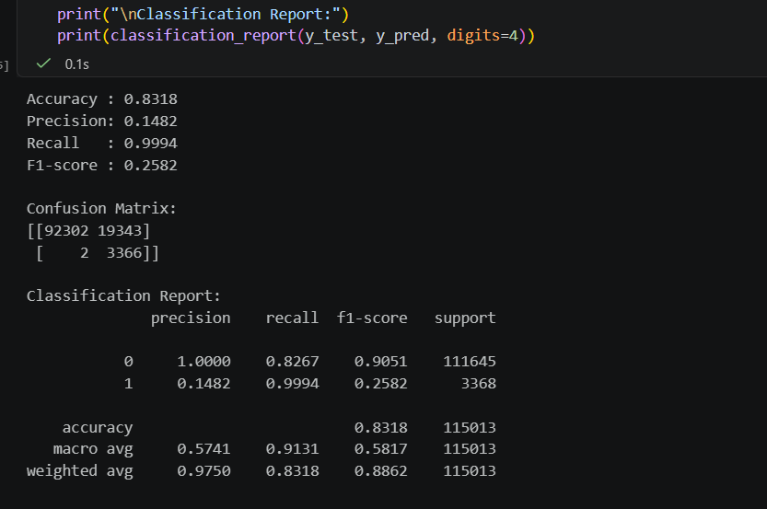
This is for the random forest model results.

Training completed.
Predicted anomaly counts:
Normal : 114,535
Anomaly: 5,465

Anomaly score summary:
count 120000.000000
mean 0.425300
std 0.038200
min 0.355100
max 0.688000
This one shows the isolation Forest scores

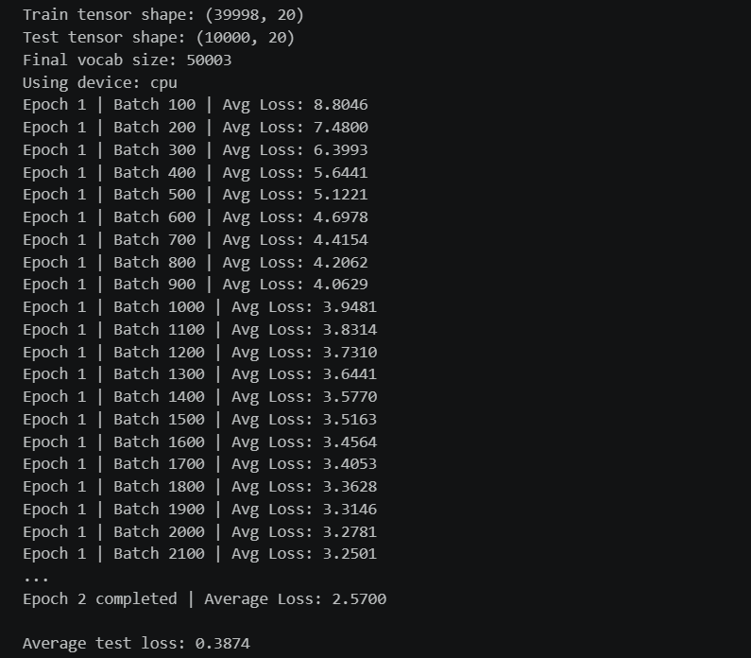
This one highlight the score of LogBERT

Model | Dataset used | Type | Main result
TF-IDF + Random Forest | HDFS_v1 preprocessed | Supervised | Default: Accuracy 0.8318, Precision 0.1482, Recall 0.9994, F1 0.2582
TF-IDF + Isolation Forest | HDFS_v2 logs | Unsupervised | Normal: 114,535, Anomaly: 5,465, mean anomaly score 0.4253, max 0.6880
LogBERT | HDFS_v2 session-based sequences | Sequence-aware deep model | Test loss 0.3874, mean anomaly score 0.3009, max anomaly score 15.5338

These results confirm that the model ran successfully, that the contamination rate of 5% was applied correctly (5,465 / 120,000 ≈ 4.55%), and that the anomaly scores have a meaningful distribution with a clear separation between the mean and the maximum. The fact that the top anomalies were then extracted and inspected — not just counted — shows that the analysis went beyond running the model to actually interpreting what the model found.

8) Cross-Algorithm Comparison and Methodology
The comparison document demonstrates technical depth through its reasoning about why different models are suited to different tasks. Specifically, the explanation of why Isolation Forest is a more appropriate baseline for LogBERT than Random Forest — because both are anomaly-detection-oriented rather than supervised classification models — reflects a nuanced understanding of the distinction between supervised and unsupervised learning paradigms and how that distinction maps onto the specific task of log anomaly detection.

The document also correctly identifies the shared limitation of both TF-IDF-based models: they treat log entries as bags of tokens and cannot capture the sequential structure of log events. This is a technically accurate and non-trivial observation. It forms the core justification for why LogBERT — a sequence-aware model — is the strongest overall choice, and it is stated clearly and precisely in the documentation.

9) Summary of Progress

Criterion | Evidence of Progress
Requirements Development | Identified chunk-based processing, text normalisation, and unsupervised modelling as key requirements; implemented all three in code
Documentation Refinement | Produced detailed algorithm comparison document covering all three models, results, limitations, and final selection rationale
Logical Progression | Followed a clear 7-stage pipeline from raw data to final model recommendation with each stage building on the last
Technical Depth | Demonstrated correct use of Isolation Forest API, TF-IDF configuration, memory management, and score interpretation
GitHub Evidence | Jupyter notebook and comparison document uploaded to project repository as verifiable artefacts of individual contribution

10) Critical Self-Assessment
During the development of the anomaly detection models, I realised that my initial ability to handle large-scale datasets and implement unsupervised algorithms such as Isolation Forest was limited. Working with the HDFS_v2 dataset exposed gaps in my knowledge, particularly in managing memory efficiently and designing a stable preprocessing pipeline.
Additionally, I found data cleaning and TF-IDF feature extraction challenging, as it required careful decisions to balance noise removal and information retention. While I was able to complete the implementation, I acknowledge that my early approach was not fully optimised. However, through continuous learning and practice, I improved my technical understanding and became more confident in handling real-world log data.

11) Challenges and Problem-Solving.
One of the major challenges was handling the large HDFS_v2 dataset, which created issues such as high memory usage, slow execution, and risk of system crashes. To solve this, I implemented a chunk-based data processing approach, allowing the dataset to be processed in smaller parts instead of loading everything at once.
Another challenge was that Isolation Forest was a new algorithm for me. Understanding how it detects anomalies and tuning parameters such as contamination required experimentation. I addressed this by testing different configurations and analysing anomaly score outputs.
Data preprocessing was also difficult, especially cleaning log data and applying TF-IDF. To overcome this, I used:
- SpaCy for efficient text cleaning and tokenisation
- Scikit-learn for TF-IDF vectorisation and model implementation
These tools helped me standardise the preprocessing pipeline and improve both performance and accuracy.

12) Evidence of Learning and Improvement
To improve my skills, I actively used online documentation and tutorials. The following resources played a key role in my learning:
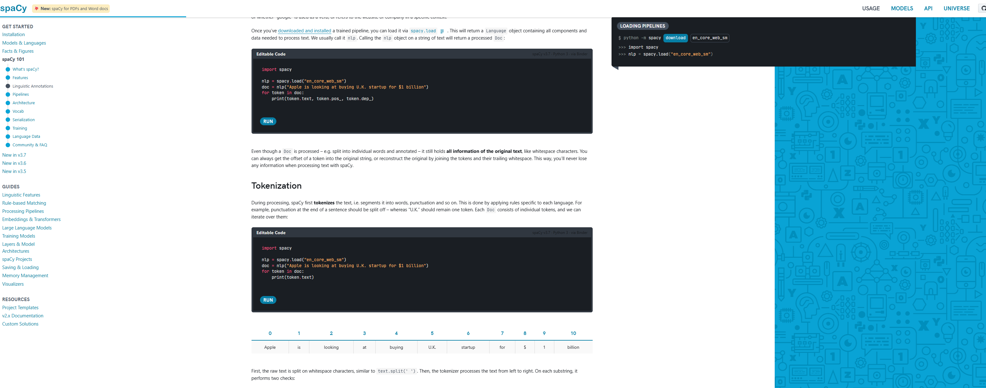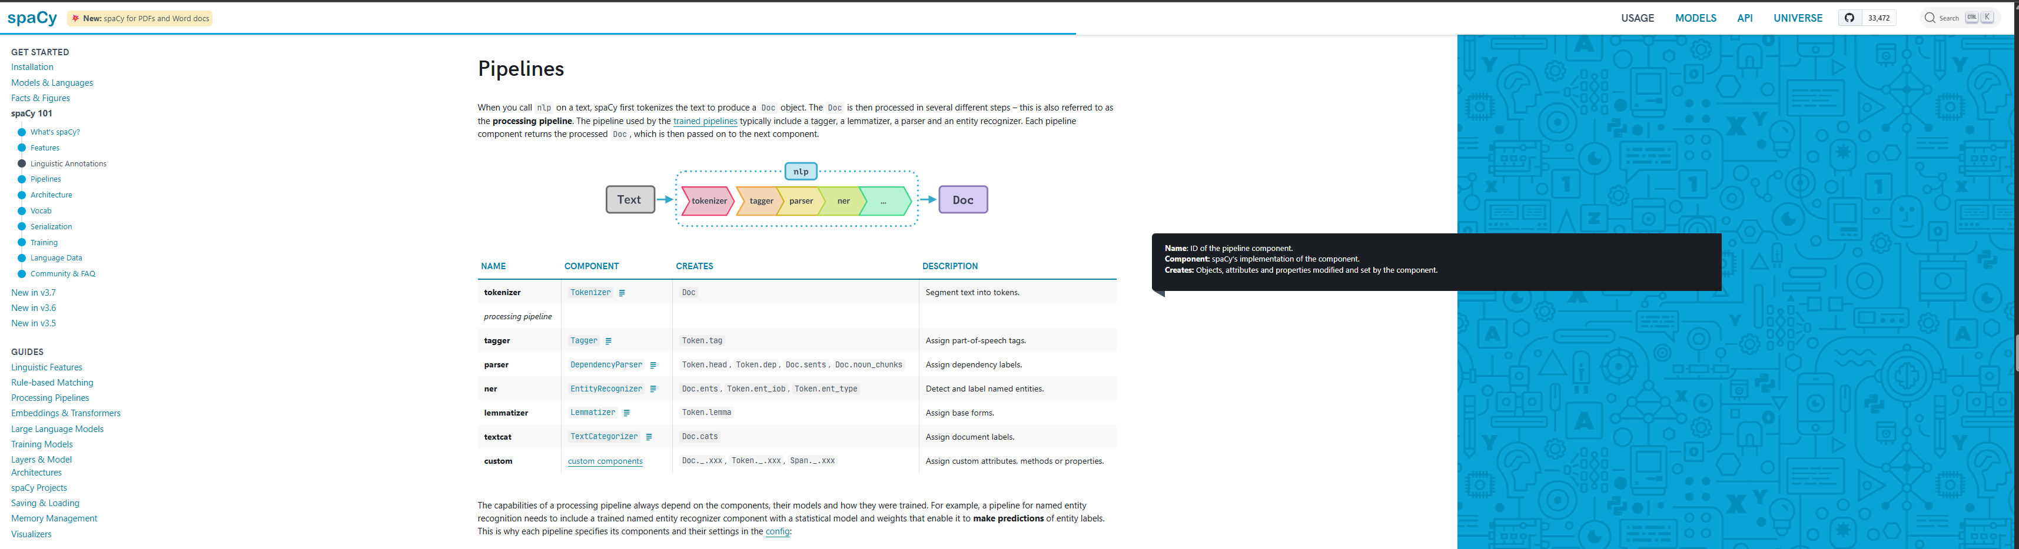

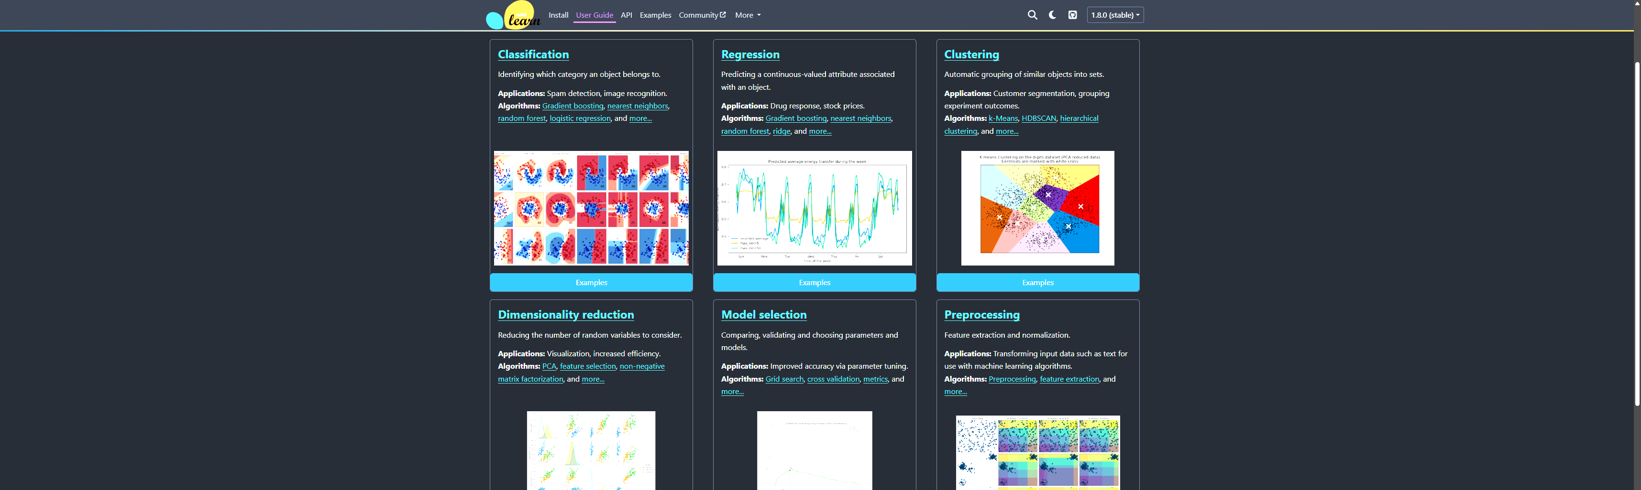

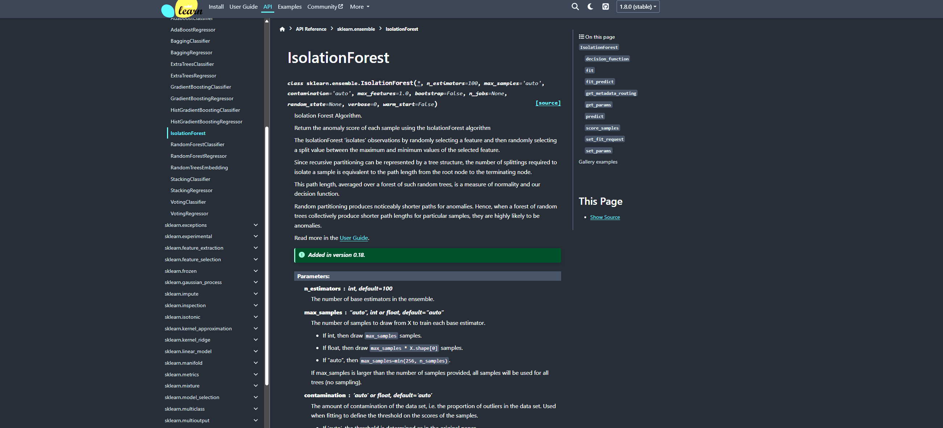

Through these resources, I developed a stronger understanding of:
- How to clean and process unstructured log data
- How TF-IDF converts text into numerical features
- How Isolation Forest detects anomalies without labels
- The practical use of Python libraries in real-world machine learning tasks
As a result, I improved both my technical implementation skills and analytical thinking, especially in debugging, model evaluation, and handling large datasets efficiently.

13) Future Thinking:
For the remaining part of the project, I have a clear plan to extend my work beyond model implementation:
- Develop a web-based system that can collect real-time log data from users
- Integrate the system with AWS services to process and store logs
- Use Amazon CloudWatch to visualise log data and anomaly detection results in dashboards
- Improve the performance and scalability of the current models
- Enhance documentation and presentation for better clarity and professionalism
